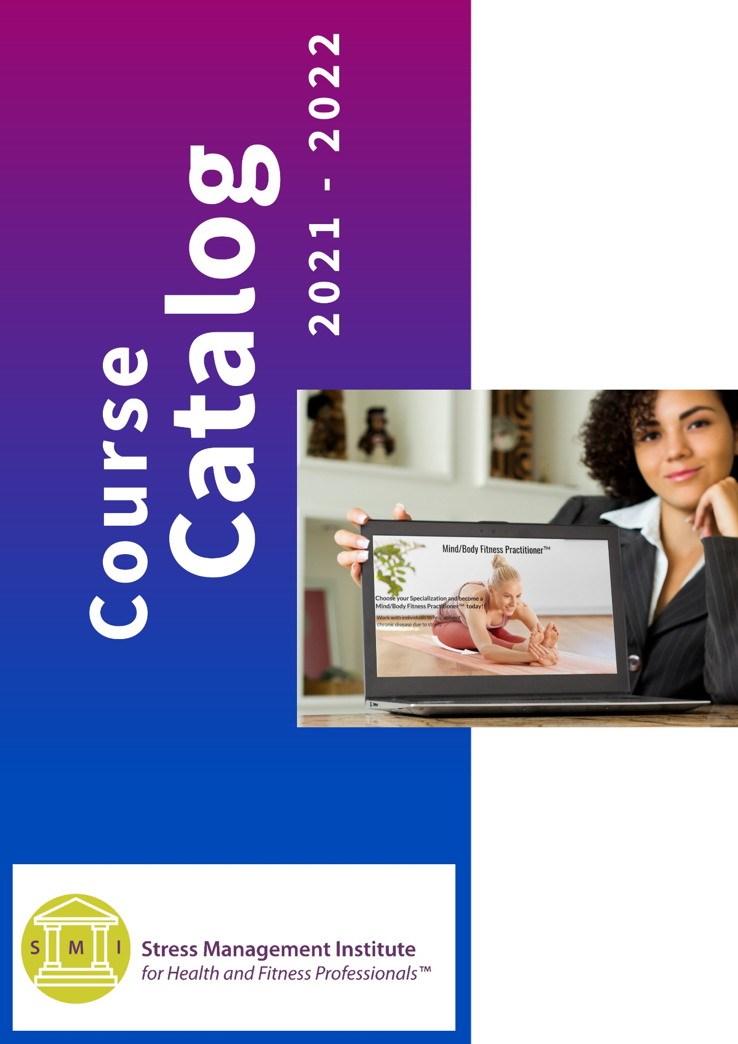
All courses come with a payment plan option!
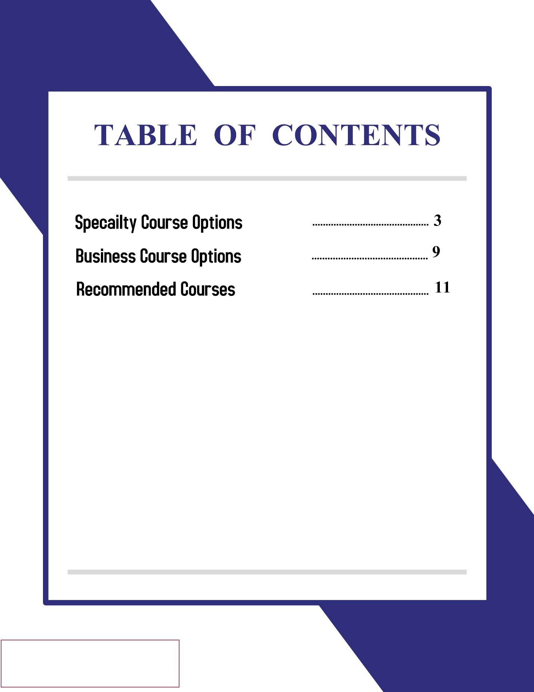

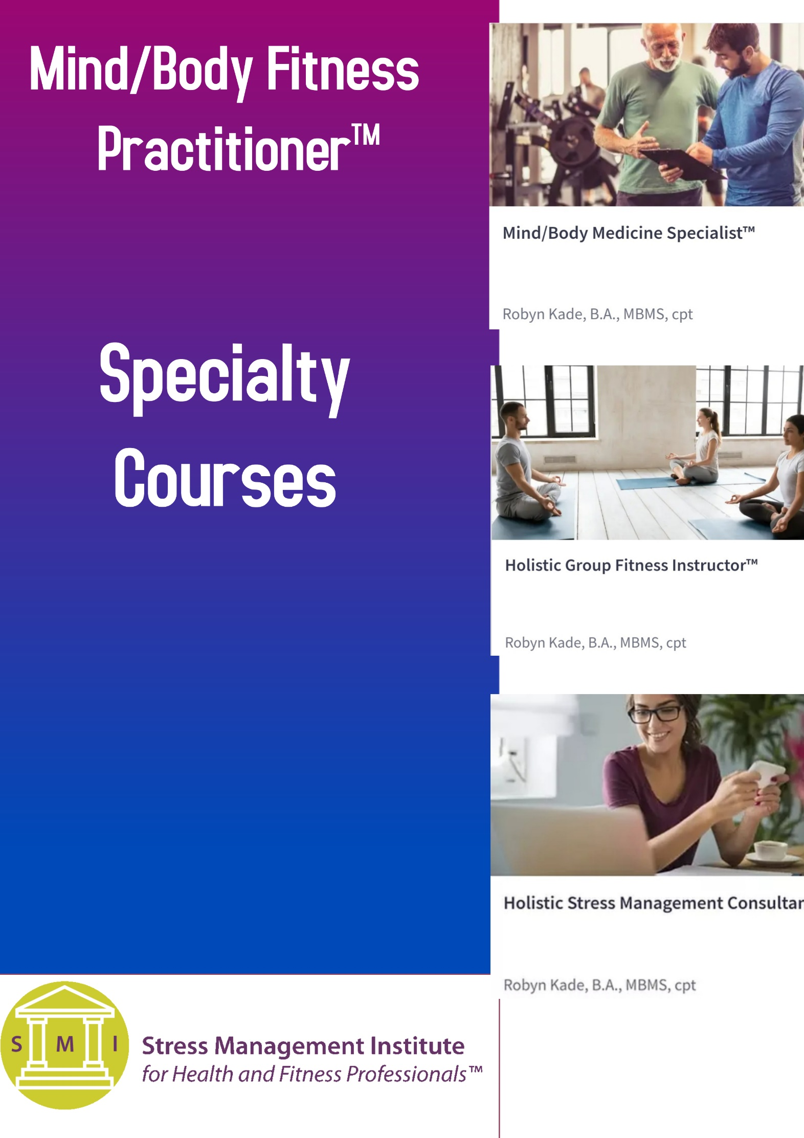
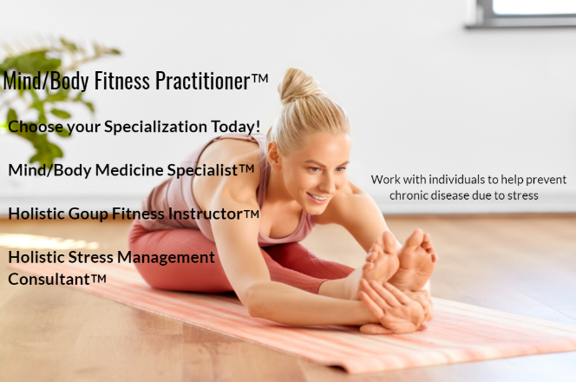
According to the American Medical Association, stress is the number one proxy killer accounting for 90% of chronic diseases around the world. Chronic stress can cause premature death from heart disease, diabetes, and other health conditions. Stress can also affect memory and kill brain cells in the hippocampus region of the brain. The American Institute of Stress states that 120,000 individuals die per year as a result of work-related stress every year. Healthcare costs are currently at an all-time high at an average of $190 billion annually. Chronic stress is also directly linked to the six leading causes of death: heart disease, cancer, lung conditions, accidents, cirrhosis of the liver, and suicide.
​
The chronic diseases that you will study in this course are Addison's disease, alcoholism, Alzheimer's Disease, angina pectoris, anxiety, arrhythmia, arteriosclerosis, autoimmune disorders, burnout, Cancer, Chronic fatigue syndrome, Chronic obstructive pulmonary disease (COPD), chronic pain, chronic tension headaches, Coronary heart disease, coronary thrombosis, Cushing's Disease, decreased immune system, depression, diabetes, drug addiction, Fibromyalgia, hypertension, insomnia, Irritable bowel syndrome, obesity, osteoporosis, memory loss, nonallergic rhinitis, obsessive-compulsive disorder, Post Traumatic Stress Disorder (PTSD), Parkinson’s Disease, psychogenic gait disorder, rosacea, stroke, and tinnitus.
We strongly believe that Mind/Body Fitness Practitioners™ must look at each client as a whole person. The Comprehensive Client-Centered Approach™ is mastered by interweaving emotional intelligence, stress resilience, mind/body programs™, and stress management wellness prescriptions to help clients throughout many aspects of their lives.

Our Mind/Body Fitness Practitioner™ courses are the most comprehensive stress management courses for the health and fitness industry. You will have the skills and tools to successfully work with clients as part of the healthcare continuum. All of these techniques combined are important for the prevention of illness due to chronic stress such as hypertension, obesity, diabetes, and many other illnesses.

It is essential to stay up to date on how mind/body medicine is evolving so you can develop safe, customizable programs and classes for anyone you work with. You will also be giving clients the power of education by incorporating health promotion techniques into their programs to help them along their journey to better health and wellness. Learn About Our Mind/Body Fitness Practitioner™ courses in more detail by scrolling down! Please note that all courses have a payment plan option. Check out our website to register today!

Mind/Body Medicine Specialist™ Course
For Certified Health and Fitness Professionals
(Includes Stress Management Exercise Prescription™ for a one-on-one- and small group training)
Price: $549.00
The Mind/Body Medicine Specialist™ works with clients in a fitness facility, corporate setting, or at their homes to provide Stress Management Exercise Prescriptions™ and mind/body programs™ for individuals who have severe, acute, and chronic stress. The individuals that you work with may or may not have a chronic disease due to stress. As a Mind/Body Medicine Specialist™, you are trying to decrease stress levels before an individual shows signs of wear and tear on the body and organs by incorporating stress management exercise guidelines and integrative wellness modalities™ into the client's Mind/Body programs™. If a client has a chronic disease due to stress, you are working with the client to decrease their stress levels before they experience a flare-up. The picture above demonstrates where we are trying to decrease stress levels in both scenarios.
Mind/Body Medicine Specialists™ will initiate our R.E.L.A.X.™ program by conducting a Mind/Body Zone™ assessment, which will enable you to analyze, assess, and classify individuals according to their fitness and stress levels. The assessment includes anthropometric measurements, a classic fitness assessment, filling out forms that will help you understand the client's quality of life, stress level, and DNA testing to give you a more in-depth look into the client's overall level of fitness and health. Please note that clients do not have to order a DNA kit to be part of our R.E.L.A.X.™ program.
As the Mind/Body Fitness Practitioner™, you would then work with your client to create a Mind/Body program™ which includes: Stress Management Exercise Prescription™, stress management coaching, mind/body art™, small group training, chronic disease self – management skill training, meditation, Shakti training, breathwork, aromatherapy, health behavior techniques, energy work, nutrition, aspects of traditional Chinese medicine that can be safely incorporated into one on one sessions, group fitness classes or small group training sessions with clients, AccuRolling™, NeuRoll Calm™ health promotion, somatic movement exercises that use meridian energy, Makka Ho Stretches, and much more. You will be using your new skillset within the personal training setting.
Holistic Group Fitness Instructor™ Course

For Certified Group Fitness Instructors
(Includes instruction on group fitness for stress management)
Price: $449.00
The Stress Management Institute for Health and Fitness Professionals™ has updated the group fitness instructor's role in the 21st century to meet the needs of today's society. Many times, individuals at a gym will only take group fitness classes. In this case, the group fitness instructor may be the only fitness professional the individual regularly comes into contact with. This is why we needed to evolve the Holistic Group Fitness Instructor™ into more of a practitioner role. This new generation of group fitness instructors is called upon to work more closely with Mind/Body Medicine Specialists™, Holistic Stress Management Consultants™, and the medical community. Holistic Group Fitness Instructors™ will offer our mind/body group fitness classes and other mind/body modalities to their class participants in either a group or private setting.
We have incorporated a Mind/Body Zone assessment™ so the Holistic group fitness instructor™ can better understand their class participant's quality of life and stress levels. We also give you access to some of the DNA tests through Toolbox Genomics so you can work with class participants on a deeper level. Only certified fitness professionals can conduct our full fitness assessment. Knowing your class participant's stress levels and disease history before taking classes can help you know how to create specialized classes for your students. Once you have this information, we teach you how to choose exercises and techniques that can specifically help each individual while instructing in a group or private setting.
Holistic Group Fitness Instructors™ will learn how to incorporate eastern and western modalities and techniques into their group classes and private sessions such as Mind/Body Myofascial Release™, AccuRolling™, Neuroll Calm™, Mindful Stretch™, health promotion, Mind/Body Art™, aromatherapy, and somatic exercises that use qi or energy that flows through the meridians of the body. The picture above demonstrates the meridians of the body and the flow of energy that may help to create homeostasis. The Holistic Group Fitness Instructor ™ will be using their new skill set within their group fitness classes and private sessions.
Holistic Stress Management Consultant™ course

For Anyone who would like to work with individuals who have acute, severe, or chronic stress. (Does NOT include any exercise instruction)
Price: $349.00

The Holistic Stress Management Consultant™ plays an integral role in the Mind/Body Medical and Wellness Continuum of Care™ by working with clients outside of the fitness setting. As a practitioner, you are meeting with clients to help them prevent or cope with chronic disease due to stress by developing Mind/Body programs™, which include: stress management coaching, mind/body art™, aromatherapy, breathwork, meditation, energy work, chronic disease self-management training, Shakti training, health promotion, and behavior change. You will also learn how to host affordable retreats to retain clients you already have while marketing to new individuals.
The Holistic Stress Management Consultant™ will administer the Mind/Body Zone Assessment™ to better understand their client's quality of life and stress levels. We also give you access to some of the DNA tests through Toolbox Genomics so you can work with clients on a deeper level. Only certified fitness professionals can conduct our full fitness assessment.

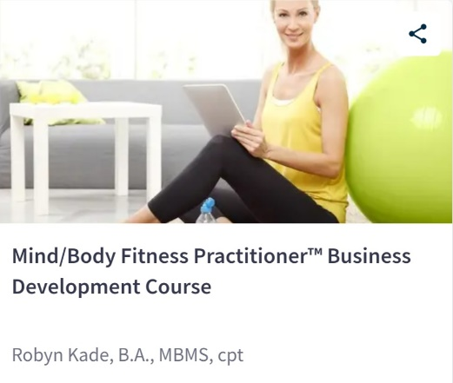
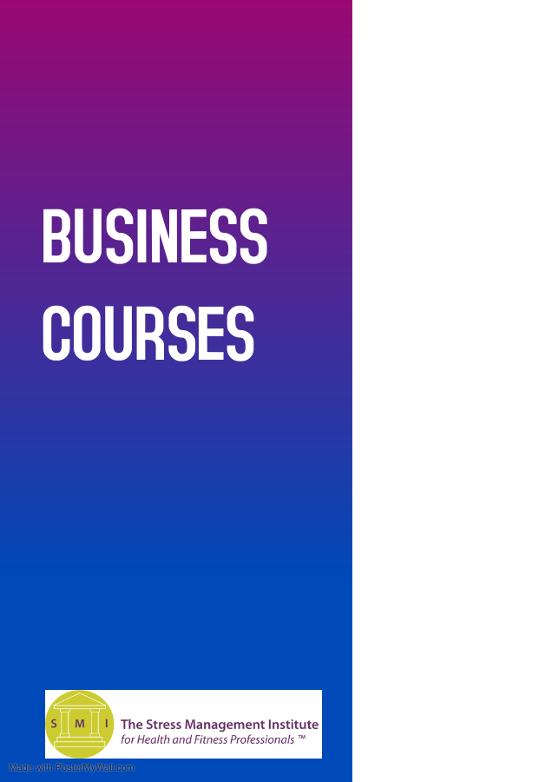
Coming October 2021
More information
coming soon!

Digital Marketing for Mind/Body Fitness Practitioners

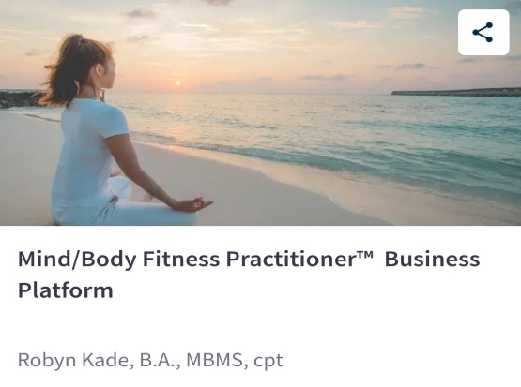

The SMI Business Institute™ can help you to create your own business as a Mind/Body Fitness Practitioner™. We take you step by step in helping you to set up and create your business in a way that is easy and affordable! We will be offering two business courses as well as our business platform, Zenlio™, which is a course as well as a back-office for Mind/Body Fitness Practitioners™ You will have everything you need at your fingertips such as easy client onboarding, white-label forms that you can add your logo too, HIPPA compliant telehealth, a personal training, and group exercise platform, online fitness and wellness assessments, five done for you programs that you can either add to your current packages or charge extra for, charting, and intake, scheduling, billing, networking, and much more!
​
By registering for Zenlio™ you will become an affiliate of the Stress Management Institute for Health and Fitness Professionals™. You may use the name Zenlio™ for marketing purposes only. The Stress Management Institute for Health and Fitness Professionals™ owns the exclusive rights to the Zenlio™ name and platform. You may use Zenlio™ in conjunction with a business you already own or start a new business. As an affiliate, you will need your own website and to register a business name as well as professional insurance. More information will be coming soon about our business institute!

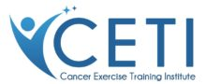
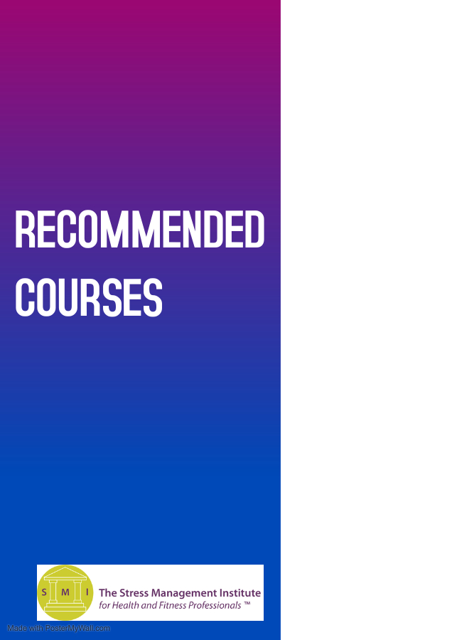
Cancer Exercise Specialist®

Natural Nutrition Coach®

Aromatherapy Certification Program
Aromahead Institute

Cancer Exercise Specialist®

Price: $749.00
The Cancer Exercise Specialist® Advanced Qualification was developed for health and fitness professionals seeking to attain a higher level of mastery and work with cancer patients during and after cancer surgery and treatment and into survivorship. Participants will gain a complete understanding of the entire cancer process from diagnosis and treatment to reconstruction and survivorship. Our unique and individualized programming will help to improve the patient’s ability to cope with the mental and physical stress following cancer diagnosis and treatment.
Our comprehensive programming covers 26 types of cancer, as well as pediatrics, with special emphasis on breast cancer and breast reconstruction. We provide two methods for obtaining your Advanced Qualification: home study and live in-person or virtual workshops. The Cancer Exercise Training Institute has trained more health and fitness professionals worldwide to become Cancer Exercise Specialists® than any other organization. Andrea Leonard, 37-year cancer survivor, PFP 2019 Personal Trainer of the Year, author of “Essential Exercises for Breast Cancer Survivors,” NASM Corrective Exercise Specialist and Performance Enhancement Specialist, ACE Certified Personal Trainer, and President/Founder of the Cancer Exercise Training Institute began her extensive research in 1995; long before anyone had ever heard of “cancer exercise.” She spent three years working on Essential Exercises with the chiefs of breast surgery at Georgetown, George Washington, and Johns’ Hopkins University Hospital Medical Centers.
Realizing there was a need to assist patients with many types of cancer, Andrea expanded her research and writing to cover a broader spectrum. She is truly a pioneer in the field of cancer and exercise and has paved the way for other organizations to follow.

Aromatherapy Certification Program

Price: $1,995.00
You’re no longer content to research and experiment on your own. You’re ready to join a growing movement of people who are transforming health and wellness, naturally. You want the highest-quality aromatherapy education available so you can feel 100% confident in your ability to use essential oils safely and effectively – and share them with others.

This course is perfect for you if:
- You want to build a clear understanding of how and why essential oils work so you can confidently use them to improve your wellness and help others
- You’re a health coach, educator, naturopath, herbalist, nurse, massage therapist, or other wellness professional looking to expand your existing career by gaining aromatherapy expertise
- You’re considering a career in aromatherapy or want to start your own essential oil business

Natural Nutrition Coach® Program

The Natural Nutrition Coach® (NNC) Certificate program:

Price: $599.00

The Natural Nutrition Coach® (NNC) Certificate program is designed to teach you the principles of healthy eating and individualized nutrition. Every person’s body is unique, but the basic principles of eating healthy and whole foods apply to everyone.

The Natural Nutrition Coach® program provides a foundation for implementing a natural foods diet as a primary modality in the pursuit of health and the prevention of chronic disease.
You will learn how to:
- Help your clients develop the habits they need to create long lasting change, and get the results they want and deserve.
- Understand the additional factors to consider when the client is doing “everything right” and not making progress.
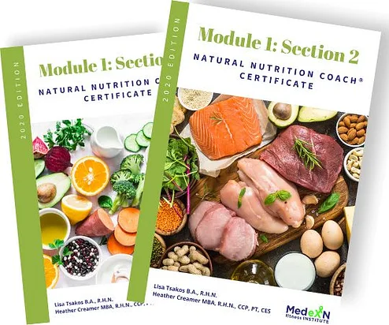
- Implement effective coaching strategies that considers the whole body, because as
Holistic Practitioners, we understand that it’s never just about the diet! It’s the Foundational Program That Will Get You Started in Nutritional Consulting!

